**AIRQUALITYMONITORING**

Phase5:ProjectDocumentation& Submission

In this part you will document your project and prepare it for submission. DocumenttheAirQualityMonitoringprojectandprepareitforsubmission. Documentation

Describe the project's objectives, IoT device setup, platform development, and code implementation.

Includediagrams,schematics,andscreenshotsoftheIoTdevicesanddata- sharing platform.

Explainhowthereal-timeairqualitymonitoringsystemcanraisepublic awareness about air quality and health impacts.

**Solution:**

# Project Title:AirQuality Monitoring

The objectives for an IoT device setup, platform development, and code implementation project can vary depending on the specific requirements and goals of the project. However, here are some common objectives that you may consider:

1. IoTDevice Setup:
   * Select and configure appropriate IoT devices and sensors based on projectrequirements.
   * EstablishareliableandsecurecommunicationnetworkfortheIoTdevices.
   * Setupdeviceprovisioningandmanagementprocesses.
   * Ensureproperpowersupplyandconnectivityforthedevices.
   * ImplementsecuritymeasurestoprotecttheIoTdevicesanddata.
2. PlatformDevelopment:
   * DesignanddevelopanIoTplatformorframeworktomanageandcontrolthe devices.
   * Create a user-friendly interface for monitoring and interacting with the IoT devices.
   * Enabledatacollection,storage,andanalysisforreal-timeandhistorical insights.
   * Implement device management functionalities such as firmware updates and remote configuration.
   * Incorporatesecurityfeaturestoauthenticateandauthorizedeviceaccess.
3. Code Implementation:
   * DevelopfirmwareorsoftwarefortheIoTdevicestocollectandtransmitdata.
   * Implementdataprocessingalgorithms onthedevicesorinthecloud.
   * IntegratethedeviceswiththeIoTplatformforseamlessdataflowandcontrol.
   * Ensureefficientpowermanagementandoptimizecodeforresource- constrained devices.
   * Implementerrorhandlingmechanismsandrobustcommunicationprotocols.
4. TestingandDeployment:
   * Conduct thorough testing of the IoT devices, platform, and code to identify and fix any issues.
   * Performintegrationtestingtoensurecompatibilityandinteroperability.
   * DeploytheIoTdevicesandplatforminthetargetenvironment.
   * Monitorandevaluatethesystem'sperformance,scalability,andreliability.
   * Continuously iterate and improve upon the solution based on feedback and user requirements.

It's important to note that these objectives are not exhaustive and may vary depending on the specific project scope, industry, and application of the IoT system.

# Diagrams,Schematics,andscreenshotsoftheIoTdevice and data sharing platform:

ThegeneralcomponentsandarchitectureofanIoTdevicesetupanddata-sharing platform.

IoTDevice Setup:

* Hardware Components: IoT devices typically consist of microcontrollers or development boards, sensors, actuators, and communication modules (e.g., Wi- Fi, Bluetooth, or cellular).
* Sensors: Various sensors can be used depending on the application, such as temperature, humidity, light, motion, or proximity sensors.
* Actuators:ThesecomponentsenabletheIoTdevicetointeractwiththephysical world. Examples include motors, relays, or LED lights.
* PowerSupply:IoTdevicescanbepoweredbybatteries,USB,orexternalpower sources, depending on the specific requirements.
* Communication:IoTdevicesneeda meansto connectto theinternetora local network. This can be achieved through Wi-Fi, Ethernet, or cellular modules.

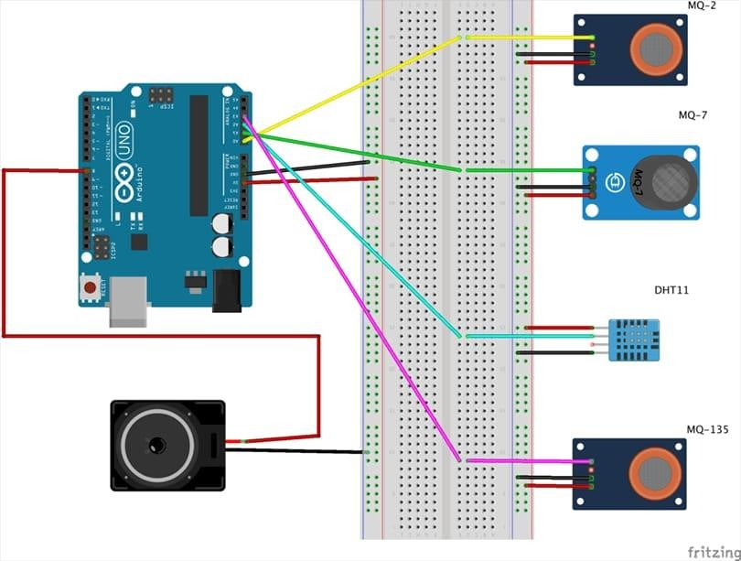

Data-SharingPlatform:

* Cloud Infrastructure: The platform typically utilizes cloud services such as Amazon Web Services (AWS), Microsoft Azure, or Google Cloud Platform (GCP) to store and process the IoT data.
* Data Collection: IoT devices send data to the cloud platform using MQTT (Message Queuing Telemetry Transport), HTTP, or other protocols.
* Data Storage: The platform stores the received data in databases such as SQL or NoSQL databases for further analysis and retrieval.
* Data Processing: The platform may include data processing pipelines or serverless functions to perform real-time data analytics, aggregation, or transformation.
* User Interface: A web-based or mobile application interface enables users to visualize and interact with the IoT data, set up rules or triggers, and control the devices remotely.
* Security: The platform incorporates authentication, authorization, and encryption mechanisms to ensure the secure exchange of data between devices and the platform.

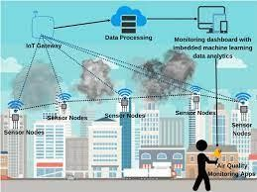

Toobtainspecificdiagrams,schematics,orscreenshotsforyourIoTprojectneed to consult relevant documentation, design tools, or work with hardware and software developers. These visual representations are typically project-specific and depend on the chosen hardware, software, and platform architecture.

# Submission:

GitHubRepository Link https://github.com/Indhujaaa/M.INDHUJA.git

# Instruction:

ToreplicateaprojectinvolvingIoTdevices,developingadata-sharingplatform, and integrating them using Python, you can follow these general steps:

1. Define the Project Scope: Clearly define the goals and requirements of your project. Determine the type of IoT devices you'll be using and the datayou want to collect and share.
2. SetupIoTDevices:ChoosetheIoTdevicesthatfityourprojectrequirements. Each device may have specific setup instructions, so refer to the manufacturer's documentationoronlineresources.Generally,you'llneedtoconnectthedevices to a power source, configure their network settings (Wi-Fi or Ethernet), and ensure they can communicate with your network.
3. Choose a Data-Sharing Platform: Select a platform or framework to handle datastorageandsharing.Somepopularoptionsincludecloud-basedserviceslike AWS IoT Core, Google Cloud IoT Core, or Microsoft Azure IoT Hub. Alternatively, you can set up your own server using frameworks like MQTT (Message Queuing Telemetry Transport), Apache Kafka, or even a custom RESTful API.
4. DeveloptheData-SharingPlatform:Dependingonthechosenplatform,you'll needtosetupthenecessaryinfrastructureandconfigureitaccordingly.Thismay involve creating topics or channels, configuring access control, and setting up datapipelines.Followthedocumentationandguidelinesprovidedbyyourchosen platform.
5. Connect IoT Devices to the Data-Sharing Platform: Implement the necessary protocols and libraries on the IoT devices to establish communication with the data-sharing platform. This typically involves using protocols like MQTT or HTTPtopublishdatatotheplatform.You'llneedtoinstallrelevantlibrariesand write code to handle device-specific functionality.
6. Develop Data Processing and Integration Logic: Using Python, develop the logic to process and integrate the data received from the IoT devices. You may need to install additional Python packages depending on your project requirements. Write code to handle data transformation, validation, and any necessary calculations or analysis.
7. Integrate IoT Data with the Data-Sharing Platform: Write code in Python to subscribetothedatapublishedbytheIoTdevicesusingtheappropriateprotocols and libraries. Retrieve the data from the data-sharing platform and process it as needed. This step may involve setting up event-driven mechanisms or periodic data polling.
8. Implement Data Visualization or Analysis: Depending on your project goals, youmaywanttovisualizeoranalyzethecollecteddata.Pythonoffersnumerous libraries and tools for data visualization and analysis, such as Matplotlib, Seaborn, or pandas. Select the appropriate tools and write code to generate the desired visualizations or perform the required analysis.
9. Test and Deploy: Test your integrated system to ensure all components are workingcorrectly.ValidatethedataflowfromtheIoTdevicestothedata-sharing platform and the integration with your Python code. Once you're satisfied with the results, deploy the solution in your target environment, whether it's a local server or a cloud-based infrastructure.

**Program:**

importpaho.mqtt.clientasmqtt

# MQTT broker configuration broker_address="your_broker_address" broker_port = 1883

broker_username="your_username" broker_password="your_password"

#CallbackfunctionforMQTTconnection def on_connect(client, userdata, flags, rc):

print("ConnectedtoMQTTbrokerwithresultcode:"+str(rc)) # Subscribe to the topic where IoT devices publish data client.subscribe("iot/data")

#CallbackfunctionforreceivedMQTTmessages def on_message(client, userdata, msg):

# Process the received messagedata=msg.payload.decode("utf-8") print("Received data: " + data)

#Performfurtherdataprocessingorintegrationasneeded

#CreateMQTTclientinstance client = mqtt.Client()

# Set username and password for MQTT broker (if required) client.username_pw_set(broker_username,broker_password)

# Set callback functions client.on_connect = on_connect client.on_message=on_message

# Connect to MQTT broker client.connect(broker_address,broker_port,60)

#StartMQTTnetworkloop client.loop_start()

#KeeptheprogramrunningtoreceiveandprocessMQTTmessages while True:

pass

Inthisexample,weusethepahomqttlibrary,whichprovideMQTTclient functionality in Python.

# ExampleOutputsOfIoTDeviceDataTransmissionAnd Platform UI:

Here'sanexampleofhowtheIoTdevicedatatransmissionandtheplatform's user interface (UI) might look like:

1. IoTDeviceDataTransmission:

Let'sassumewehaveanIoTdevicethatmeasurestemperatureandhumidity. ThedeviceperiodicallypublishesitsreadingstotheMQTTbroker.Here'san example output of the device data transmission:

Topic:iot/data

Payload:{"temperature":25.5,"humidity":60.2}

Inthisexample,thedevicepublishesthetemperaturevalueof25.5degrees Celsius and the humidity value of 60.2%.

1. PlatformUserInterface (UI):

Theplatform'sUIallowsuserstoviewandanalyzethecollectedIoTdata. Here's an example of how the UI might display the received IoT data:

| DataDashboard |

| Timestamp | Temperature | Humidity |

|  |  |  |  |
| --- | --- | --- | --- |
| |2023-10-3110:00:00| 25.5 | | | 60.2 | | |
| |2023-10-3111:00:00| 26.0 | | | 58.9 | | |
| |2023-10-3112:00:00| 24.8 | | | 62.5 | | |
| | ... | ... | ... | |  |  |  |

In this example, the UI presents a data dashboard where the timestamp, temperature, and humidity values are displayed in a tabular format. The table shows a history of the received data, with each row representing a different timestamp and its corresponding temperature and humidity readings.

The UI can also include additional features such as data visualization, real-time updates, and options to filter or export the data. These features depend on the specific requirements of your project and the capabilities of the chosen data- sharing platform and visualization libraries.

Remember, the actual appearance and functionality of the UI will depend on your project's design choices, the platform you use, and the specific implementationdetails.Theexamplesprovidedhereserveasastartingpointto illustrate how the IoT device data transmission and the platform's UI might look.